

European Parking Association
Richartzstraße 10 D- 50667 Köln
Tel.: +49 221 257 10 18
epa@europeanparking.eu
www.europeanparking.eu
EUROPEAN STANDARD PARKING AWARD 2022
The European Parking Standard Award (ESPA) is instituted by the European Parking Association to improve the quality of service, provided by the parking industry to its customers. It must be clear that car parks, compliant to the ESPA invite visitors to enter and leave their car in a trustworthy environment. The ESPA is granted to public accessible car parks that meet a set of requirements of quality to provide safe and comfortable parking service to the visitors. Car parks that do not meet the ESPA requirements are not disqualified for operation but will not be honored with the plaque to demonstrate compliance to the European Parking Standard Award.
To be able to assess whether a car park meets the standards as set by the EPA, the attached checklist has been set up. In order to qualify for the standard, the car park first of all must fulfill a set of basic requirements, outlined in chapter 1. Once the basic requirements have been fulfilled, a minimum of 50% score of the total list is required and defined minimum scores at each chapter 2 through 11. A car park that achieves the total score but does not achieve the minimum score in each section, does not qualify for the standard.
To obtain an objective and balanced judgement the criteria are split up. Minimum score to pass each category is 40% (30% on comfort & miscellaneous and 25% on energy & environment). This enables compensation if a car park just meets the minimum requirements on certain subjects. Extra bonus/minus points can be of decisive influence to reach the required 50% overall score.
On top of the standard ESPA award an ESPA Gold award has been defined for exceptional quality of service. The ESPA Gold requires a 65% score of the total checklist. Minimum score to pass each category is 50% (40% on comfort& miscellaneous and 25% on energy & environment).
The European Parking Association has delegated the judgement and presentation of the ESPA - Award to the national parking associations. The checklist is available in 7 local languages.
The Award is granted as long the car park meets the defined standards. It is up the national parking association to require a re-assessment after some time to check, whether the car park is still compliant to the requirements. On the ESPA-Award plaque will show the year when the award was first issued.
EPA claims the right to withdraw the Award (through the national organisation) if the car park no longer meets the necessary requirements to deserve the European Standard Parking Award.
The ESPA checklist is developed as a self-calculating Excel scheme, including automatic assessment for the standard ESPA or the ESPA Gold award. This document explains how to work with the scheme in general and explains how to assess the detailed items by chapter.
The Excel scheme can be downloaded from the EPA website, Awards, ESPA.
0 Starting an assessment
At the opening sheet “General info” the language can be chosen and general navigation is supported:
- The “start” button erases existing information in the Excel workbook and the workbook can be saved with a project related name.
- The “print checklist” button automatically prints the entire workbook of 15 pages.

The data on this General Info page do not have any effect on the scoring of the project.

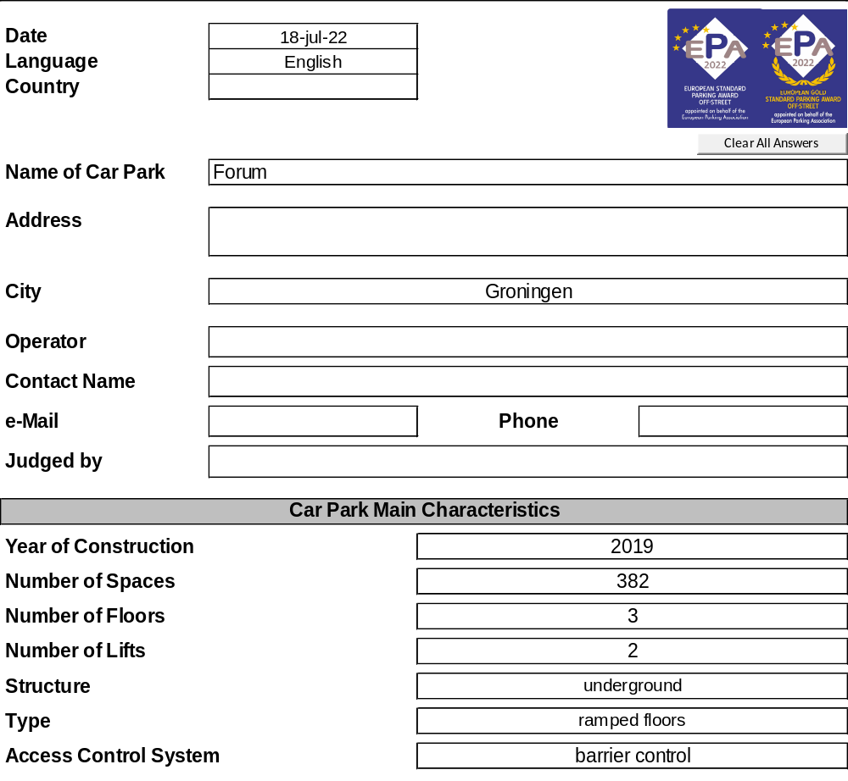
The evaluation sheet is fully self-calculating and does not require any input. The information provided on this page will be explained later in this manual.
1 Mandatory Minimum conditions
1.1 Car parks must be for public use, dedicated car parks for subscribers only cannot qualify.
1.2 The general headroom in the car park must be minimal 1.90 meters. Incidental lower obstacles at some parking bays (i.e. sewage pipes, ventilation units) are allowed but should be clearly marked.
1.3 Public car parks with only one combined lane for entrance and exit do not qualify.
1.4 70% of the parking bays must be at least 2.30 meters wide. The increase from older checklist-versions reflects the increase of width of the cars during the last 15 years and the effect that doors must be opened wider due to side impact protection within the doors. To prevent many older car parks from exclusion on forehand and keep stimulating renovation of older car parks, an exemption has been made for renovated car parks, over 10 years old. In those cases bay widths between 2.25 and 2.30 meters are allowed with a penalty of 5 points, to be compensated elsewhere (i.e. better lighting or better marking). This penalty will be effectuated as Minus-points at item M8.
1.5 Straight ramps require minimum width of 2.70 meters. Width of straight ramps is to be measured between pillars or walls, as for the cars width over the mirrors is the most critical measures.
1.6 The width of the ramps can be measured easily; radius often cannot be measured directly. This can be calculated from measuring the chord of the circle: For the minimum radius of 8 meters the chord (deviation between curve and straight connection line between two points) over 4 meters length must be maximum 25cm. If this is more, the radius is less than 8 meters and the car park does not qualify.
1.7 Ramp gradients should not exceed 20% at the steepest part in the center of any driving lane. Ramp gradients, especially on entry and exit are important elements in driving comfort and safety perception of the car park.
1.8 Contactable staff may be either local in the parking facility or on remote basis. Service (opening doors, barriers) should be possible by contacted staff.
1.9 A proof of payment must be provided at the pay-point on request.
1.10 In the general routing of the car park all turning movements must be possible without necessity to reverse. This includes driving from entry to parking spaces and from parking spaces to the exit of the car park. Moving in and out of individual parking bays and incidental cul-de-sacs may include reversing.
1.11 For safety reasons a minimum light level of 20 Lux on the parking floors has been defined. This minimum refers to the average light level value on the parking floor, at some spots or corners a lower level might be found incidentally.

At each item entered compliant “OK” of “Fail” the score is kept at the bottom of this worksheet. Once all items have been entered the score will show “Complete” and “Pass”.

2 Lighting
In the Excel sheet the actual measured light levels need to be entered in the green shaded cells. The system calculates the scores awarded, using the formulas displayed.
Measured light levels relate very strong to the distance between measure point and light source. At the entry, exit, pay machine and cashier desk (items 2.2 – 2.5) the light level is to be measured at the height level of action (1 meter above the floor), the other measures are to be made at floor level.
At multistorey car parks (MSCP) with open facades it must be safeguarded to measure the light without influence of sunlight. If the car park is equipped with daylight compensation facility, this will be assessed at chapter 10, energy & environment.
2.8 To obtain reliable and representative light level results for the parking floor a grid of ten measuring points has been defined. The grid consists of two lines (both right-angled to the driving direction), one line basically under the light fitting and the second line basically just in between the light fittings, with each five measuring points:
- At the end of the parking bay
- Halfway the parking bay and the edge of the driving lane
- At one edge of parking bay and driving lane
- At the center of the driving lane
- At the other edge of the driving lane and the opposite parking bay
It is obvious to give relatively more emphasis on the driving lanes of the parking floor than the parking bays, due to the intensive use of the traffic areas. The measurement of light levels at the parking bays should be done in the absence of parked vehicles. In case of continuous lighting lines (i.e. LED lines) 5 meter distance between both lines of five measuring points can be taken. With continuous LED-lines both lines will give almost the same results.
Experience of light levels is partly based on the light level on the spot, but also on the uniformity of light levels. Hence on the parking floor not just the average light level will be calculated but also the uniformity. The uniformity of light levels relates to the calculated standard deviation of the light levels in the defined grid of ten measuring points. The scores for average and uniformity will be calculated automatically from the ten individual measuring values entered.

Once all items on any of the scoring-worksheets have been entered, the scoring ribbon on top of the sheet shows “Completed” and the score of this chapter will be displayed, as shown below:

The percentage expresses the actual score from the maximum score of this chapter. The category value expresses the weight factor of this chapter in the overall score. The points awarded express the contribution to the final score of 100% maximum score, of which 50% to achieve the standard ESPA award and 65% to qualify for the ESPA Gold award.
3 Car Entry/Exit
3.4 Information on opening hours and tariffs should be available at the car entrance of the car park. As the driver just passes by, the information should be compact and understandable within seconds and readable from about two meters distance. Readability should be assessed within this context.
3.5 This item assures that the driver can easy drive along the ticket machines at the entry or exit, to reach easily to the ticket machine to take or present tickets or cards, without necessity to open the door of the car.
3.6 This item deals with slopes at the entry and exit, preferably not to use the brake while taking or presenting tickets or cards.
3.7 Curb design to avoid damage to vehicle’s heels usually is achieved by chambered curbstones with an angle of about 45°. Line markings without heighted areas provide the least risk of damage to wheels.
3.9 Access security in this item relates to facilities, available during daily operation hours. Security during evening and night is assessed at item 7.6.
3.10 At the entrance the license plate of the car is read and included in the ticket. Once paid for the parking transaction at the pay-station, the license plate number is connected to the payment. This enables the exit to open automatically, without inserting the parking ticket.
3.11 Width of the net opening is to be measured between construction (pillars or walls), taking into account elements at about 1 m height, as for the cars width over the mirrors is the most critical measures.
3.12 Certain distance between the end of an exit ramp and crossing pedestrians and/or cyclists is important to provide a safe situation for traffic, exiting the car park.
4 Parking area
4.1 Placement of pillars is very important for safety and comfort while moving the car in and out of the parking bay and entering/exiting the car by driver and passengers. Ideal situation is when pillars do not intrude the parking movement at all: pillars (or walls) are situated at the end, outside the parking bay. Next best is placement of pillars at the end of the parking bay (last 1 – 1,5 meter) and the front of the car can be parked next to the pillar.
Placement of pillars at the beginning of the parking bays do hamper the car turning in and out of the parking bay. Placement of pillars halfway the parking bay hamper de driver and passengers while getting in and out of the car. Both situations are not honored with any points.
4.2 If pillars are on the edge of the parking spot, they can be protected (with soft materials) to avoid damage to cars, in case of a light touch.
4.4 However it may not be necessary or obliged to have signage in car parks conform to national road code signs, it is seen as beneficial, as every road user will recognize the signs and this will contribute to unambiguous signage.
4.9 Width of bays is to be measured between the centers of the separation lines between bays. In case of angled parking the bay width is to be measured at right angle to the direction of the bay (“b” in the next scheme) and not the angled front along the aisle, which is longer (“g” in the next scheme). A bay width between 2,25 and 2,30 meters is only allowed for older renovated car parks, according to the mandatory condition #4. In those cases a penalty of five minus points applies at item M8.
4.10 Recognizing the complex correlation of angled parking, bay width and aisle width for the comfort of use of the car parks, there is a need for simplification to compromise a reasonable assessment.
The effective aisle width depends on the depth of bays: if bays are only 4.50 meters, parked cars will impact into the effective aisle width. To get along, the total unit of two parking bays and the aisle width (measure B) will be assessed. Parking bay width is measured at item 4.8.
Comfortable measures “B” depending on bay width and parking angle are based on a driving curve simulation tool, using a normative car of 4.72 meters long and 1.77 meters wide (refers to cars like Audi A4, Mercedes C, Peugeot 508 and Volkswagen Passat; also smaller cars like Peugeot 308, Renault Megane, Mercedes A, Audi A3 and Volkswagen Golf are almost 1.80 meters wide). For the maximum score the normative car can just turn into the parking bay without reversing, when using the ideal driving line. In day to day practice drivers might need to reverse to get in and out the parking bay, not using the ideal driving line. At lower scores reverse movements always will be necessary, to get in and out the parking bay.

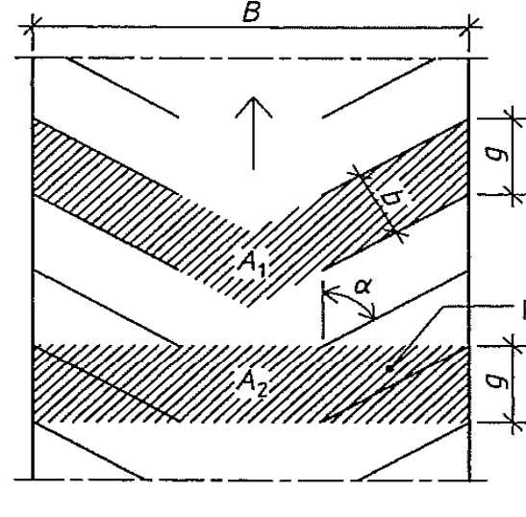
Parking angles can be measured directly with a gradient device or estimated from the tangent at the front side of the parking bay: 90°: 0,00 ; 85°: 0,09cm/meter ; 80°: 0,18cm/meter ; 75°: 0,27cm/meter ; 70°: 0,36cm/meter ; 65°: 0,47cm/meter ; 60°: 0,58cm/meter ; 55°: 0,70cm/meter ; 50°: 0,84cm/meter ; 45°: 1,00

5 Vehicle Ramps
A single level car park without ramps between the parking levels receives 10 points. This includes an underground single level car park with only entry and exit ramps and no internal circulation ramps.
5.4 With a radius of 8 meters the chord (deviation between curve and straight connection line between two points) over 4 meters length is 25cm. This can be measured with a line of 4 meters long with a marking point at the middle. At a radius of 10 meters the chord over 4 meters length is 20 cm. If this is less, the radius is more than 10 meters.
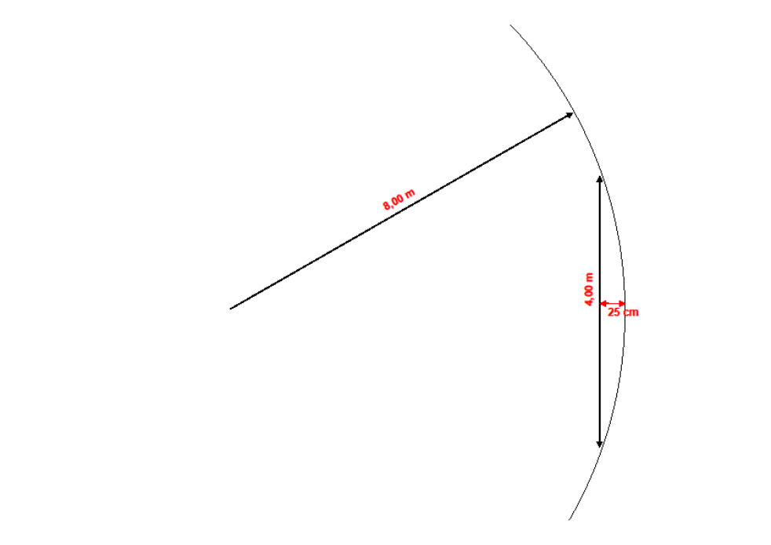
5.5 Easy access to curved and straight ramps is important for (perceived) safety while driving through the car park. Narrow 90° turns to ramps or even U-turns should be avoided.
5.6. Ramped parking floors bring discomfort for the parkers, especially while getting in and out of the car, and cause additional damaging risk with buggies and shopping carts. A slope of 5% means 5cm per meter.

6 Pedestrian Access
This section deals with stairwells and elevators in the car park and pedestrian routes including pedestrian entrances for general use by parking customers. Dedicated elevators for specific user groups (i.e. residents) and emergency exits should not be considered here. In case of more public accessible stairwells and/or elevators the average is to be assessed. If there is a clear hierarchy of main stairwells and secondary facilities, the score can be compensated in the last item of the bonus/minus section.
6.3 Pedestrian entrance doors refer to entrance from outside the car park.
6.4 Controlled pedestrian access during daytime will be assessed here. Car park access with season ticket ID-devices during evening and night, will be assessed in the next chapter at item 7.7.
6.10 Doors directly to the parking area refer to the connection between elevator hall/staircase and the parking floor. The most valued connection is wide, open and transparent, to be valued at the maximum 7 points. A transparent glass door, to be opened by the visitor is valued at 3 or 5 points, depending on the width.

7 Security equipment
7.2 Staff surveillance can either be on-site or remote, using intercom and CCTV. Remote surveillance include follow-up of CCTV and intercom alerts. Remote staff surveillance is to be tested with intercom button at an entry, exit or pay station. On site staff surveillance scores additional points at item 7.5.
7.5 This item refers to recognizable, company dressed, staff in the car park, to assist customers.
7.6 From security point of view speed gates, closing after each car, operational day and night, are most awarded with 4 points. .
7.7 Lockable pedestrian access during evening and night is awarded at this item. Controlled pedestrian access at daytime is assessed at item 6.4.

8 Way finding inside and outside of the car park
8.1 Indication of vacant spaces can be displayed by dynamic signage. Individual stall vacancy usually is indicated by red and green light signals at the ceiling.
8.2 Identification of floor levels and sections is of special importance for larger car parks. In smaller car parks it is usually easier to find the way in the car park and score of adequate is easier to achieve.
8.8 However issues, addressed here are generally outside the direct responsibility of the car park operator, installation can often be influenced and are part of the total service package to the customers. A dynamic guidance system towards the car park showing available spaces is awarded with 2 points extra.
8.11 Guidance for pedestrians refers to signage outside the car park: at the pedestrian exit to key attraction points around the car park and signage to direct to the pedestrian entrance.
9 Comfort & miscellaneous
9.2 Payment options at pay stations refer to car parks with barriers (with pay-on-foot stations) and to car parks with Pay & Display systems.
9.3 Payment options at exit refer to barrier-controlled car parks, where the barrier can be opened by the payment transaction at the exit.
9.4 Payment based on ANPR might be connected to an account, charging regularly to a bank account or indirectly through a credit card.
9.5 At this item first the type of payment needs to be specified: pay & display (yes) or barrier controlled (no). From there one of both next cells appears green shaded and one of the available options can be selected, to score the points for this item.
9.13 A pick-up point can either be a serviced desk or lockers with a code to open inside the car park, i.e. at the pedestrian entry area.
10 Energy & Environment
10.1 LED-lighting or T5-tubes are examples of energy saving lighting systems.
10.2 Refers to switchable/dimmable light, depending on movements in the car park or in sections of the car park. The car park should not get completely dark. A minimum light level should be maintained to remain perceived quality.
10.3 Refers to light adaption to outside light conditions, i.e. different light levels at the entry/exit at daylight or night situations, preventing driving into “a dark hole”.
10.4 Refers to light adaption to outside light conditions on the parking floor at open MSCP’s. At full daylight the lighting system near the outside walls can be reduced.
10.7 Refers to use of semi clean water (not drinking quality) for cleaning purposes etc.
10.8 Electric charge points are defined as access points, one unit can have two sockets and counts as two charge points. The average capacity per charge point is to be calculated based on the capacity of each individual charge point. The total smart power is the maximum power to be delivered to all connected charge points at the same time, based on the maximum capacity of the connection of the car park to the electrical grid network.
10.10 Refers to European or national guidelines for recycling of new buildings at the end of lifetime.

B Bonus/Minus points
M7/B10 Extra bonus and/or minus points can be awarded for issues not covered in the chapters before.
M8 In case of an old, refurbished car park with bay width between 2,35 and 2,30 meter the penalty of 5 points must be confirmed here.
B11 A life-care plan refers to planned maintenance during the lifetime of the building.
B12 Sustainability & recycling plan refers to use of sustainable building materials and re-using of materials at demolition of the building at the end of the lifetime.

Global evaluation
Upon entering data in the checklist, the progress can be monitored in the global evaluation sheet. Status and scoring are displayed by chapter.
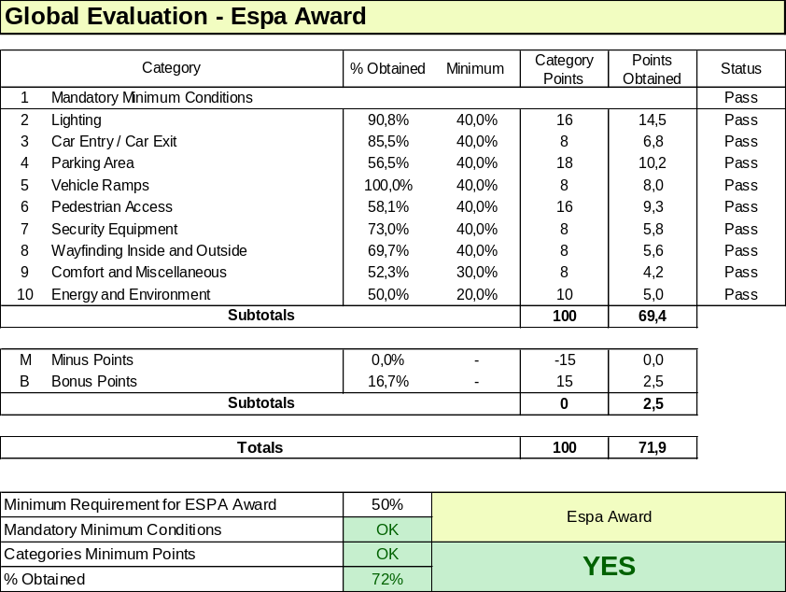
Once all items are completed the final score is displayed and “YES” if the car park qualifies for the ESPA award.
A separate evaluation sheet has been added for the ESPA Gold Award, including some additional mandatory conditions and higher scores required for each chapter:
- Minimum headroom 2,00 meter instead of 1,90m.
- Minimum bay width for 70% of spaces 2,40 meter instead of 2,30 m.
- Average light level on the parking floor minimum 50 Lux instead of 20 Lux.
- Minimum requirement per chapter generally raised from 40% to 50%, , chapter 9 raised from 30% to 40%.
- Overall minimum requirement is 65% of scores instead of 50%.

The differences reflect the ESPA standard award being a requirement for basic quality for all public car parks and the ESPA Gold award for car parks, providing premium quality to its customers. The ESPA gold standard will be marked with a special sign, emphasizing the higher quality level.
